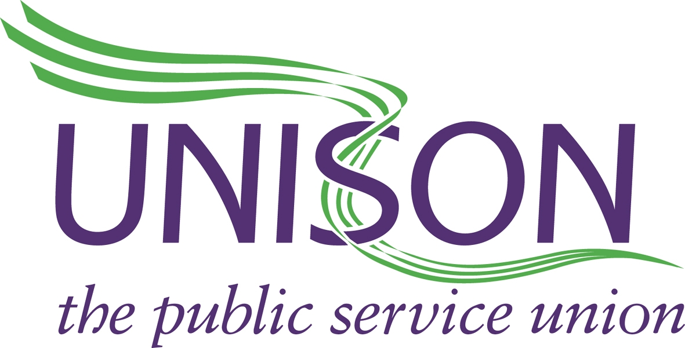

UNISON DIRECT 08000 857 857

YORKSHIRE AMBULANCE SERVICE BRANCH
www.uyab.co.uk Date: 12/03/18
Nomination Form for North and East Convenor

UNISON Membership Number –
Base Station - | Please only vote for one candidate by placing an x in the box opposite the name below.
Neil Woods
Sue Forth
Gary Hagan

Return to –
UNISON,
Yorkshire Ambulance Service,
Brindley Way,
Wakefield,
WF2 OXQ

Alternatively you can vote online by emailing unisonvote@yas.nhs.uk

CLOSING DATE FOR BALLOT WILL BE – 1700hrs Monday 9th April 2018

Membership numbers can be obtained by calling UNISON Direct on 08000 857 857

