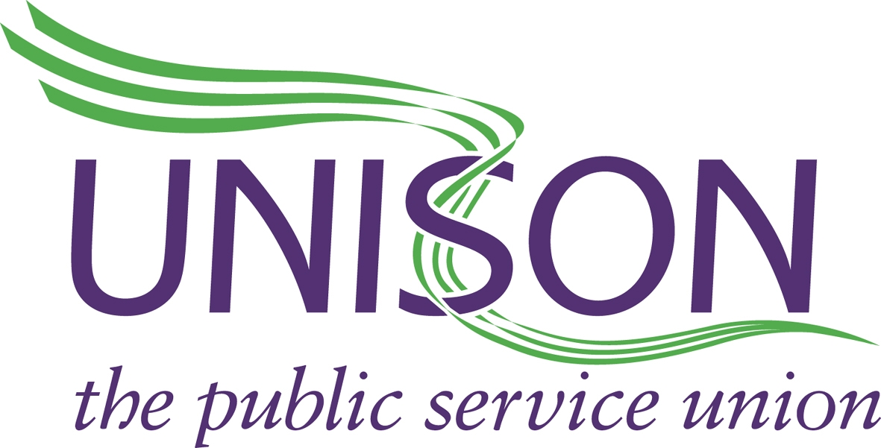

YORKSHIRE AMBULANCE SERVICE BRANCH
www.uyab.co.uk Date: 06/10/17

Dear Rod

UNISON has endeavoured to work with the Trust over the last couple of years, to try and enhance the service for the patients of Yorkshire that we serve, as well as improving the working conditions and lives of our members.
In forming agreements with the Trust we feel as a union we are following our members mandates in order to achieve the above goal. However it is becoming increasingly clear that the Trust feels that although agreements are made, they do not have to adhere to them if they do not see fit.
The approach that Trust management are taking is unacceptable, and directly impacting on our member’s health, wellbeing and morale. Despite UNISONs best efforts to try and resolve the frustrations of our members, when they are at the receiving end of these blatant flouting of policies, our informal, partnership approach appears to not be making any progress.
UNISON now feels that only a stronger approach is available to us, this is supported by our members in recent correspondence with them. Lip service is no longer an option, only a full and formal commitment to meet with UNISON in order to resolve these problems, can avert a much stronger course of action from the Branch. Issues include:

- A and E transformation programme being ignored, including all the agreed policies
- Forced changes to members annual leave processes without any consultation
- Failure to fill rota lines despite the agreements in place
- Unacceptable delays in regards disciplinary process and again failing to follow policy
- Changes to PTS shifts done at short notice with an expectation members will work ‘extra’
- Annual leave/TOIL being blocked, despite being available
- End of Shift working reaching unacceptable levels
- Members being refused retire and return
- Still no ACAS binding arbitration date to resolve PTS meal break issue
- Equality issues being ignored

- Failing to abide by agreements –RRVs being taken off cars despite written agreement against such action
- Not aligning vehicles to staff working patterns so hours are lost
- Annual Leave /TOIL blocked or being told that short notice leave is now not an option.
- Rotas being left empty despite staff available
- Increasing reliance on private providers

- Relief rota/agreement ignored

This is by no means an exhaustive list, with our members in many departments within Trust frustrated at how they are being treated.
We see the Trusts new modern set of visions and values being promoted, with the expectation that our members adhere to them, but where is the one team spirit and integrity when agreements are being broken on a daily basis? Currently there appears to be little direction within the Trust, which is directly impacting on our members.
UNISON now feels that until the Trust meet with us to discuss and correct all the issues raised by our members, of which only a fraction are listed above, UNISON in the first instance will be withdrawing from all future meeting with the Trust, as we have always entered agreements in good faith and in the belief that they will be upheld, without this assurance and action from the Trust, further meetings will be pointless.

