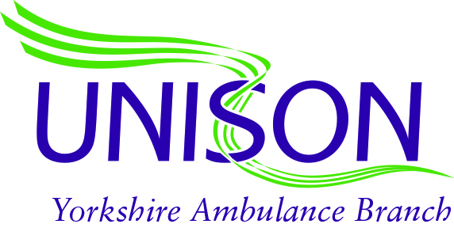 [](http://www.rcn.org.uk/)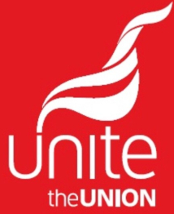

12th March 2021

Dear Rod,

As joint Trade Unions it is our aim to represent members to the best of our ability, always with integrity and dedication, whilst maintaining the values of our unions and those of the Trust. It is therefore extremely concerning that as a joint staff side feel we have no choice but to raise the current situation that has arisen within Yorkshire Ambulance Service with you.

The position that we now find ourselves in is not something that has just occurred, it has been building up over a period of time, but most recently it has reached a point where to continue in an obviously flawed process would make staff side complicit in the wrongdoing.

Job evaluation is a process that should be a shining example of partnership working, an equal partnership that should triumph mutual respect, reflecting the Trusts own vision and values. Unfortunately it is becoming abundantly clear that this is not the case. For a senior member of the Trust to openly accuse senior Trade Union representatives working on the panels of manipulating the process and lacking integrity is disgraceful, especially when staff side are able to evidence serious issues within the Job evaluation process, including management trying to overly influence panel outcomes.

The actions of the senior manager has been the straw that broke the camel’s back and caused damage to already fraught working relationship that may never be repaired. If staff side had followed the same course of action, there would undoubtedly have been an investigation; however it appears that the other way round it is acceptable and is a damning reflection of the breakdown of partnership working currently within YAS.

In the spirit of our understanding of partnership working, and with our ultimate aim of representing our members best interests, staff side are requesting an urgent meeting of senior Trade Union reps and Trust management to resolve the current situation around the relationship between management and staff side, and ultimately to move forward outstanding banding reviews as well as resolving other job evaluation issues. It would be hypocritical of staff side to continue to engage in a process that currently is flawed, we therefore have taken the decision to withdraw from all job evaluation processes until the current concerns and issues of staff side are resolved. The only exception to this will be the Clinical Supervisor role, which already has ACAS involvement, and it is felt that to include external agencies in an internal dispute would be unreasonable.

Joint Trade Unions