Yorkshire Ambulance Branch
01/03/2017
Transporting Patients with own oxygen

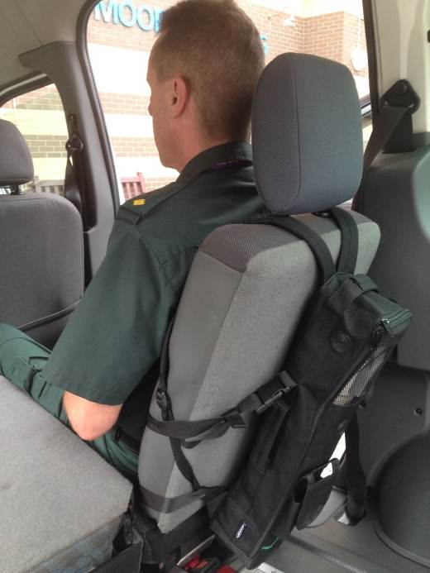
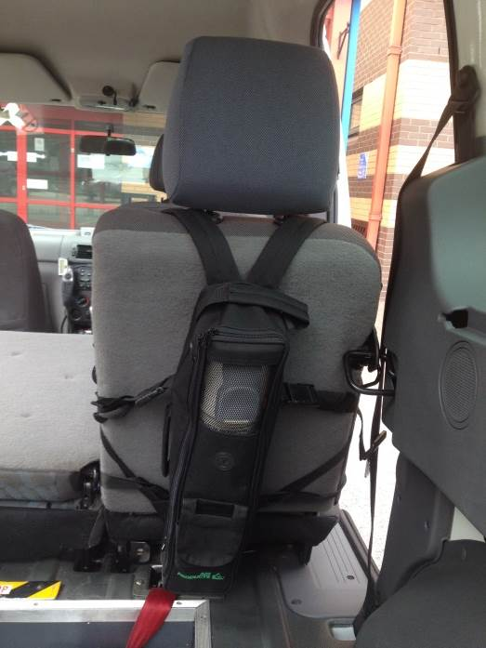

The pictures above show the only bags that patients can use when being transported by PTS across the TRUST

It has been reported to UNISON that patients are using all types of bag (even well-known supermarket carrier bags) Patients can only bring one cylinder, if they require more they should be upgraded to a double handed crew.

UNISON Branch Committee

