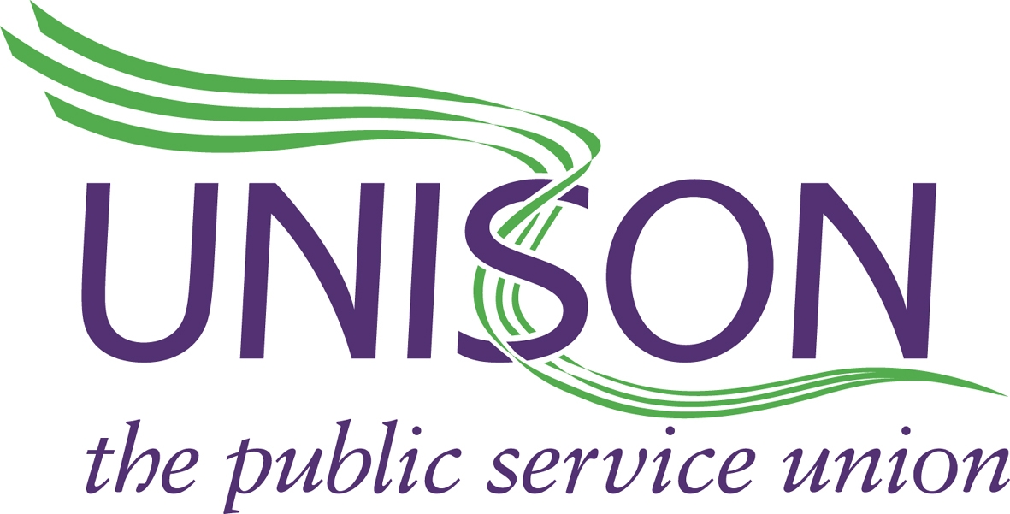

UNISON DIRECT 08000 857 857

YORKSHIRE AMBULANCE SERVICE BRANCH
www.uyab.co.uk Date: 28/10/16

UNISON MEMBERS STATION MEETINGS. ROTA REVIEW.

THE FOLLOWING NORTH AREA STATION MEETINGS HAVE BEEN PLANNED TO DISCUSS THE ROTAS RECENTLY ISSUED BY THE TRUST, THE ACCOMPANYING POLICIES, THE CONSULTATION PROCESS AND DETAILS AROUND THE SUBSEQUENT VOTE RELATING TO ALL OF THE ABOVE, ALONG WITH ANY OTHER CONCERNS STAFF MAY HAVE.

THURSDAY 3RD NOVEMBER.
HARROGATE 1230-1400

WEDNESDAY 9TH NOVEMBER.
SELBY 0900-1030

THURSDAY 10TH NOVEMBER.
NORTHALLERTON 1000-1130
KIRKBYMOORSIDE 1300-1430

FRIDAY 11TH NOVEMBER.
FILEY 0900-1030
MALTON 1130-1300

PLEASE MAKE EVERY EFFORT TO ATTEND.

